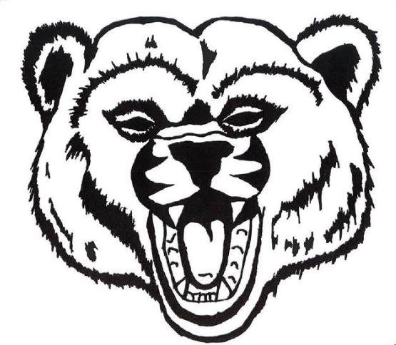
The Bear Facts
Scotia Union School District Monthly Newsletter/November, 2020

October ended with a lot of excitement! Even with all the current changes and guidelines, our students and staff still found ways to participate in Red Ribbon Week activities, The Great American Shake Out, bus safety training, our annual Halloween rock hunt, Halloween storytimes, and amazing Halloween activities in place of our annual Halloween Parade downtown. Thank you to Scotia’s business community for generously donating treats for our school-based festivities!

DAYLIGHT SAVINGS TIME starts November 1. Time to set the clocks back one hour!
VETERANS DAY is Wednesday, November 11. School will be closed in observance of our veterans.
SCHOOL PICTURE RETAKE DAY is Wednesday, November 18.
THANKSGIVING BREAK is the week of November 23-27, and WINTER BREAK is December 21-January 1.

This month, we will have multiple virtual performing arts presentations, including “Ned’s Kindness Adventure”, and the plays “The Caterpillar Hunter” and “Scrooge”.
Mrs. Scharnberg, our music teacher, is developing a “Celebration of Learning” that will be shared with families in December, highlighting visual and performing arts performances of our students.

The First Trimester ends November 20. Please contact teachers prior to the end of the trimester with any questions or concerns regarding your child’s grades. Teacher email addresses can be found on the school’s website. Report cards will be sent home after Thanksgiving Break.

Distance Learners- We will soon be sending out a survey to our distance learning families. Families can fill out the survey online or on paper.

In place of monthly awards assemblies, we are holding monthly classroom-based awards presentations.
Congratulations to our STUDENTS OF THE MONTH for September and October: Kymorah Wong, Bricen Vital, James Dinsmore, Violet Costa, Emma Hatten, Antonio Cervantes, Bethannie Shahid, Bailey Keppler, Emily Capik, Weston Chadbourne, Jubal Tuey, Hudson Gardner, Brogan Dillon, Madison Jones, Branson Rumley, Dax Parrott, Braelyn Regan, Etta Jane Meaux, Cade Church Parrott, Miley Finch, Bryce Jones, Josh Hindley
Congratulations to our SWAG AWARD WINNERS for September and October: Ruka Paine, Xenoclea Vaughn-Miller, Rosemary Amaral, Dawson Butterfield, Kiera Freeman, Tiki Bolden, Bentley Poczulp, Zachary Harris, Apollo Perkins, Lillian Herriot, Logan Gibney, Kara Dinsmore
Students in each class who follow BEARCODE are entered into a monthly drawing for a BEARCODE t-shirt or BEARCODE mask!
BEARCODE
SAFETY---RESPECT---RESPONSIBILITY

UPCOMING DATES
Sunday, November 1 Daylight Savings
Wednesday, November 11 Veteran’s Day - No School
Thursday, November 12 School Board Mtg./7:00
Wednesday, November 18 Picture Retake Day
Friday, November 20 End of First Trimester
November 23-27 Thanksgiving Break

